Fabulous Filtration
Name: Class:

Draw some of the ways you use water, every day, in the boxes below:

We all need water to survive.
Unfortunately, lots of the water we use is getting polluted!

What do you think pollution means?
________________________________________________________________________________________________________________________________________________________________________________________________________________________________________________

How can you make water clean?
We can make a filter to clean some of the pollution out of water. Your teacher has made a home-made filter.
Can you draw and label the filter?

Draw a picture of your water before it goes in the filter.
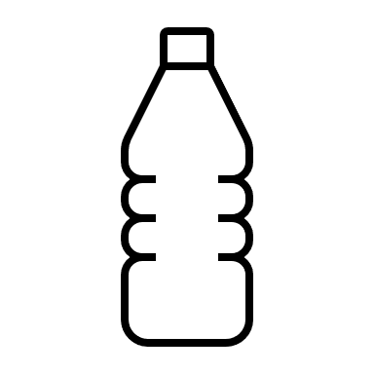

Draw a picture of your water after it goes through the filter.
Did the filter help clean your water?
________________________________________________________________________________________________________________________________________________________________________________________________________________________________________________

Would you drink this water? Why/Why not?
________________________________________________________________________________________________________________________________________________________________________________________________________________________________________________

