Fabulous Filtration
Name: Class:

We all need water to survive.
List some of the ways we use water every day.
________________________________________________________________________________________________________________________________________________________________________________________________________________________________________________

Unfortunately, lots of the water we use is getting polluted!
What do you think pollution means?
________________________________________________________________________________________________________________________________________________________________________________________________________________________________________________

What problems does water pollution cause? Look at the pictures for clues.
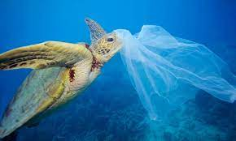
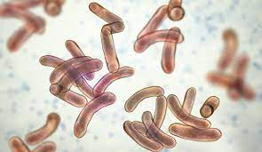
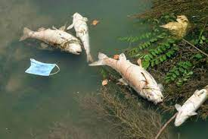
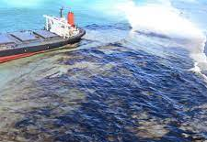
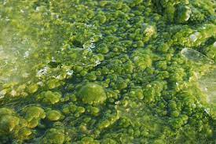
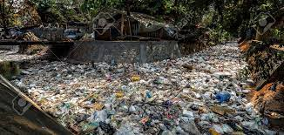

________________________________________________________________________________________________________________________________________________________________________________________________________________________________________________
ACTIVITY
How can you make water clean?
We can make a filter to clean some of the pollution out of water.
These are the materials you will need.
- 2 l Coke or similar bottle (recycled please)
- Gravel
- Sand
- Serviettes/coffee filters
- Cotton wool
- pollution substitute (sand, food waste, bits of plastic, food colouring, cooking oil, spice etc.)
You will be using the design process to make your filter.

Investigate
Why do we need to clean water?
________________________________________________________________________________________________________________________________________________________________________________________________________________________________________________

Design
Using the materials supplied above, design the water filter best suited to cleaning pollution out of water. Draw your filter in the box below, remember to label it clearly.

Make
It is time to make and test your filter system. To make “polluted” water, mix water with sand, leaves, some food colouring, tiny pieces of plastic and paper and a bit of oil.
Draw a picture of your water before it goes in the filter.
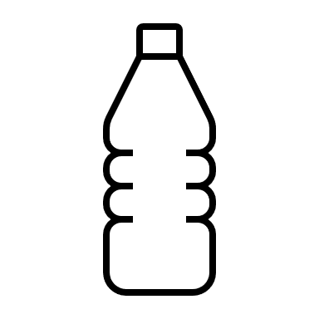
Draw a picture of your water after it goes through the filter.

Evaluate
Did the filter help clean your water?
______________________________________________________________________________________________________________________________________________________________________________________________________________________________________________________

Would you drink this water? Why?
______________________________________________________________________________________________________________________________________________________________________________________________________________________________________________________

How could you change in your filter to make it more efficient?
______________________________________________________________________________________________________________________________________________________________________________________________________________________________________________________

Communicate
Write down all the steps needed to make your filter.
____________________________________________________________________________________________________________________________________________________________________________________________________________________________________________________________________________________________________________________________________________________________________________________________________________________________________________________________________________________________________________________________________________________________________________________________________________________________________________________________________________________________________________________________________________________________________________________________________________________________________________________________________________________________________________________________________________________________________________________________________________________________________________________________ _________________________________________________________________________________________________________________________________________________________________________________________________________________________________________________________________________________________________________________________________________________________________________________________________________________________________________________________________________________________________________________________________________________________________________________________________________________________________________________________________________________________________________________________________________________________________

