Fabulous Filtration

Name: Class:

How do you think we can easily and inexpensively clean water?
We can make a filter to clean some of the pollution out of water.

These are the materials you will need:
- 2 l Coke (or similar) bottle
- Gravel small
- Gravel large
- Sand
- Serviettes
- Old socks
- coffee filters
- Cotton wool
- Activated charcoal
- pollution substitute mixed in water (sand, food waste, bits of plastic, food colouring, cooking oil, spice etc.)

You will be using the design process to make your filter.
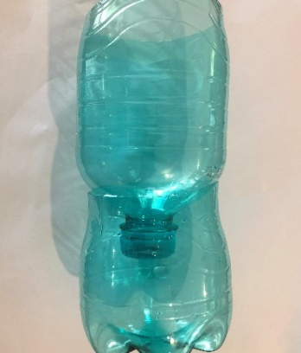
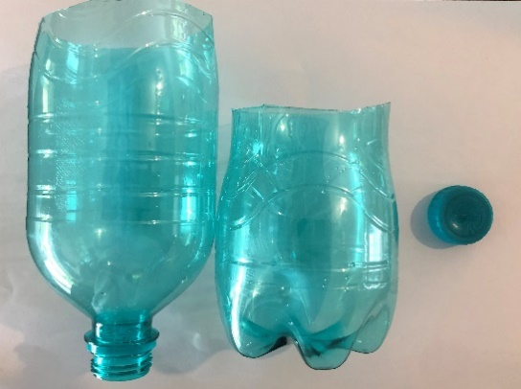

To begin, you need to test the filtering capacity of each filtering component. To make “polluted” water, mix water with sand, leaves, some food colouring, tiny pieces of plastic and paper and a bit of oil.

Investigate
Which filters/ filter combinations do you think will work best to filter out contaminants?
Filter Type | Type of pollution removed
Old sock
Cotton wool
Coffee Filter paper
Sand filter
Soil filter
Small gravel filter
Large gravel filter
Charcoal filter
Serviettes

Test
You will need to test the individual filter components to get a general idea of their filtering abilities.

Prediction
I predict that__________________________________________ (my filter combination type e.g. sand, gravel and cotton wool) will filter the water best, because________________________________________________________________________________________________________________________________________________________________________________________________________________________________

Design
Using the materials test above (you can use all the above or as many as you need), design the water filter best suited to successfully cleaning pollution out of water. Draw your filter in the box below, remember to label it clearly.

Make
It is time to make and test your filter system.
Draw a picture of your water before it goes in the filter.
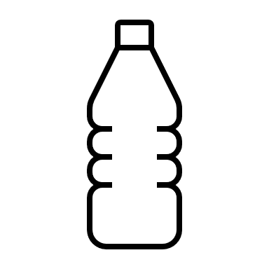
Before After

Describe your observations of your water BEFORE filtration (smell, colour etc):
______________________________________________________________________________________________________________________________________________________________________________________________________________________________________________________
Describe your observations of your water AFTER filtration (smell, colour etc):
______________________________________________________________________________________________________________________________________________________________________________________________________________________________________________________

Evaluate
My prediction was right/wrong? Why?
______________________________________________________________________________________________________________________________________________________________________________________________________________________________________________________

Did the filter work as expected? Explain.
______________________________________________________________________________________________________________________________________________________________________________________________________________________________________________________

Would you drink this water? Why?
______________________________________________________________________________________________________________________________________________________________________________________________________________________________________________________

Do you think the filtered water is clean enough to put into a river? Explain.
______________________________________________________________________________________________________________________________________________________________________________________________________________________________________________________

What could you change in your filter to make it more efficient?
______________________________________________________________________________________________________________________________________________________________________________________________________________________________________________________

Communicate
Write down all the steps needed to make your filter.
______________________________________________________________________________________________________________________________________________________________________________________________________________________________________________________________________________________________________________________________________________________________________________________________________________________________________________________________________________________________________________________________________________________________________________________________________________________________________________________________________________________________________________________________________________________________________________________________________________________________________________________________________________________________________________________________________________________________________________________________________________________________________________________________________________________________________________________________________________________________________________________________________________________________________________________________________________________________________________________________________________________________________________________________________________________________________________________________________________________

Can you think of some clever ways to help clean our water in our rivers and dams?
____________________________________________________________________________________________________________________________________________________________________________________________________________________________________________________________________________________________________________________________________________________________________________________________________________________________________________________________________________________________________________

